Week 10 Thermometer CDAC Implementation
Final weekly report through November 1 2026
Team Member: Henan | Week 10 | October 31 to November 1, 2026
Course: AMS Senior Design | Project: Programmable Bias Voltage DAC

Completed this week: thermometer unit, array, driver, testbench and first nominal transient. The code 3-to-4 zoom shows no visible undershoot. Available binary MOS-reset comparisons differ by 8.6 uV at code 4 and 12.5 uV at code 7; full static and dynamic characterization remains open.

Question 1
Based on the overall specifications you set for your project, what specifications should this block meet?
The 3-bit prototype retains eight equal unit capacitors: seven independently switched units and one fixed dummy. With Vu=1 V, Vl=0 V and an initial reset at code zero, the ideal outputs are 0 through 0.875 V in 0.125 V steps. The comparison should preserve total capacitance, reference voltages, reset sizing, timing and load. A quantitative glitch or settling acceptance limit has not yet been agreed.

Question 2
What simulations do you need to run to verify this block meets those specifications?
Completed: nominal code scan and a zoom of the ascending 3-to-4 transition under TT, 27 C, 1 V with a 0.5 um/60 nm reset. No undershoot is visible in the 185-205 ns zoom. Still needed: matched binary comparison, residual-glitch and settling measurements, reverse transition, code-zero and common-time voltage samples, temperature corners and long-hold tests.

Question 3
Why is this block a proper selection for your application and your overall specifications?
This implements the mentor suggestion to investigate thermometer coding for the switching-related drop. Binary code 3 to 4 changes three weighted branches in opposing directions; the thermometer sequence changes one equal unit from Vl to Vu. The new zoom supports reduced visible disturbance. Total switch count also changes from 6 to 14, so the improvement cannot be attributed to encoding alone without further controlled tests.

Question 4
What are the main challenges in designing this block?
Seven independent reference selections require 14 TGs, versus 6 in the binary design, and 28 scalar control pins. Using the same TG dimensions increases total switch area and parasitics and changes drive distribution. The implementation must avoid duplicate control names, floating reference connections and incorrect library references. The earlier TG OFF-current value remains provisional because numerical sensitivity and leakage paths were not resolved.

Question 5
What circuit- or system-level solutions address those challenges?
I built the reusable unit and seven-unit array, copied the top-level design into bias_voltage_dac, and generated the symbols. I expanded cdac_therm_driver to seven unit controls and resolved the xrun PATH/port-synchronization issue in the active Virtuoso session. The assembled testbench produced the staircase and clean-looking major-carry transition. Quantitative glitch/settling verification, decoder hardware, sizing optimization and broader PVT work remain unfinished.

Implementation status
This week I completed the reusable Cu plus two-TG unit, seven-unit thermometer array, array symbol, expanded Verilog-A driver and wired testbench. The array uses eight equal capacitors including the dummy, fourteen TGs and a physical NMOS reset. The first nominal transient and a code 3-to-4 zoom demonstrate the ascending staircase without the formerly prominent undershoot at the displayed resolution.
The nominal test uses tt_lib at 27 C, VDD=Vu=1 V, Vl=VSS=0 V, reset W=0.5 um/L=60 nm and a 400 ns transient. The reset size and enabled TT_27 corner were confirmed. The original implementation and waveform figures are retained below. Formal netlist auditing and numerical-convergence checks remain open.

Remaining work
Next work: use matched sample times and effective numerical settings for the binary comparison; measure residual glitch and settling to an agreed band; test reverse transitions and long hold. Thermometer temperature/process corners, loaded operation, INL/DNL and layout are unfinished. TG OFF-current tolerance/gmin validation remains paused. The earlier mentor requests on TG ON/OFF behavior and thermometer switching remain the guidance; no additional feedback is recorded.

Thermometer CDAC array schematic
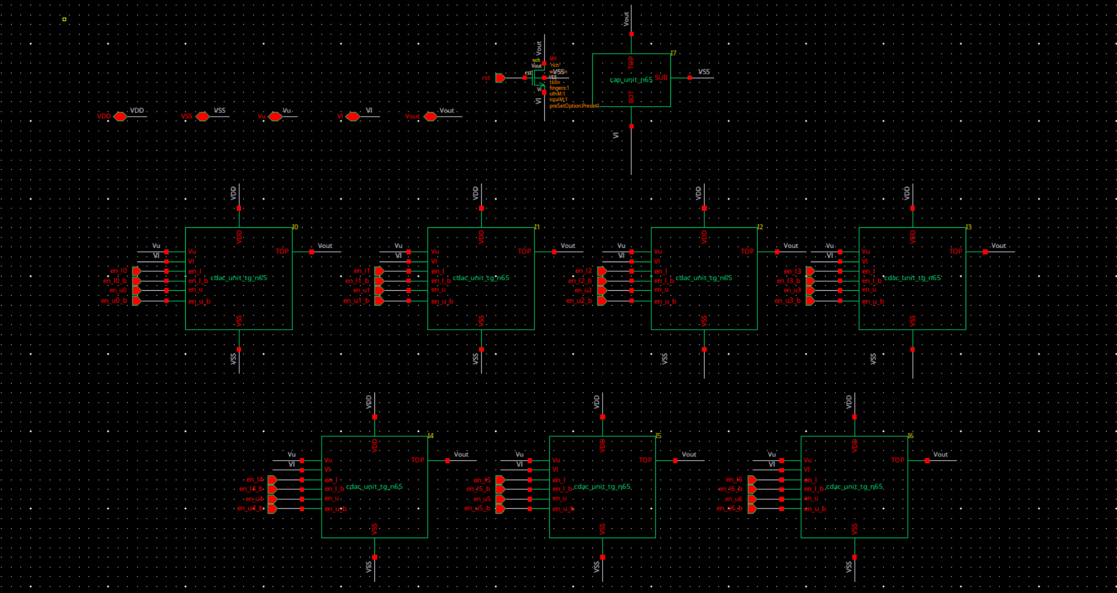
Figure 1. Full 3-bit thermometer CDAC: seven Cu plus two-TG units, one fixed dummy capacitor and one MOS reset. The designer confirmed the connections; this is the supplied original schematic image. The first transient is reported later in this document; quantitative binary-versus-thermometer verification remains pending.

Reusable unit schematic
Cell cdac_unit_tg_n65 contains one unit capacitor and two transmission gates. Its TOP pin connects to the common array output. The internal bot node connects the capacitor BOT to both TG A terminals; the TG B terminals select Vu or Vl. VDD and VSS bias the TG bodies, and the capacitor SUB connects to VSS.
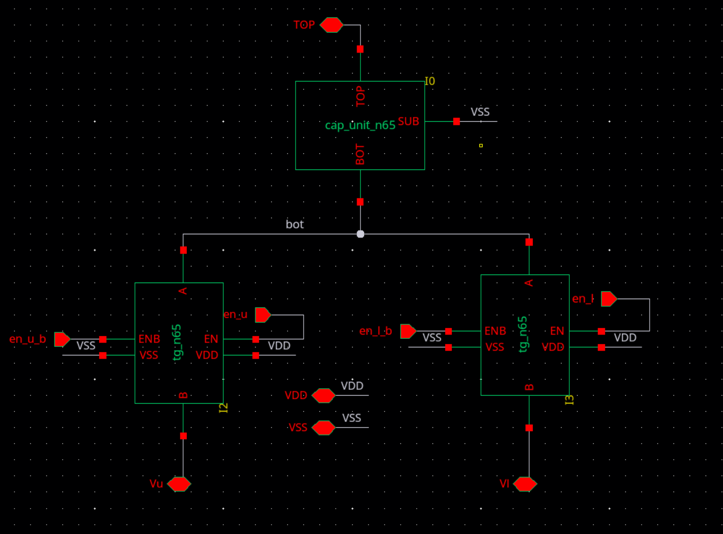
Figure 2. Internal schematic of the reusable unit, corresponding to the descend view: one cap_unit_n65 and two tg_n65 instances. Upper and lower paths have independent EN and ENB inputs for external nonoverlap control. The dummy and reset are placed at the array level, outside this unit.

Thermometer array symbol
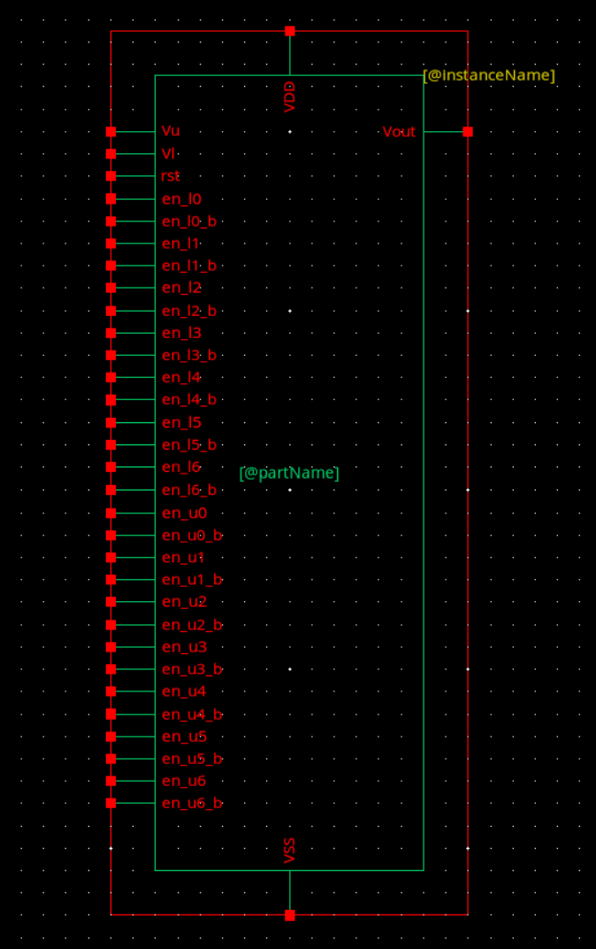
Figure 3. Generated 34-pin thermometer array symbol: 28 control pins, Vu, Vl, rst, Vout, VDD and VSS. The driver symbol was separately regenerated to 30 terminals and the user confirmed that port mismatch cleared. A first transient is now available; the generated netlist remains to be audited.

Thermometer Verilog A driver
The cdac_therm_driver Verilog-A view is now open in bias_voltage_dac with the expanded seven-unit interface entered. It has 28 TG-control outputs, rst and vss, for 30 terminals. The screenshot confirms the interface and default timing parameters; simulator behavior is documented separately by the first transient waveform later in this report.
The prepared code scans k=0 through 7. Its upper-path mask is (1 << k) - 1; the remaining units connect to Vl. Only changing units are disconnected during the 5 ns break-before-make interval. Make events start at 35, 75, 115, 155, 195, 235, 275 and 315 ns, with 1 ns edges. Initial reset releases at 20 ns; the second reset runs from 350 to 370 ns while the array stays at code 7. These are intended stimulus behaviors, not measured waveforms.
A separate mask-logic check covered all eight codes and found no simultaneous logical upper/lower enable on a unit. The 30-pin driver symbol is regenerated, the user reports no remaining port mismatch, and the testbench wiring is assembled. A first transient is now available. Netlist auditing, detailed waveform checks and quantitative glitch/settling comparison remain pending.
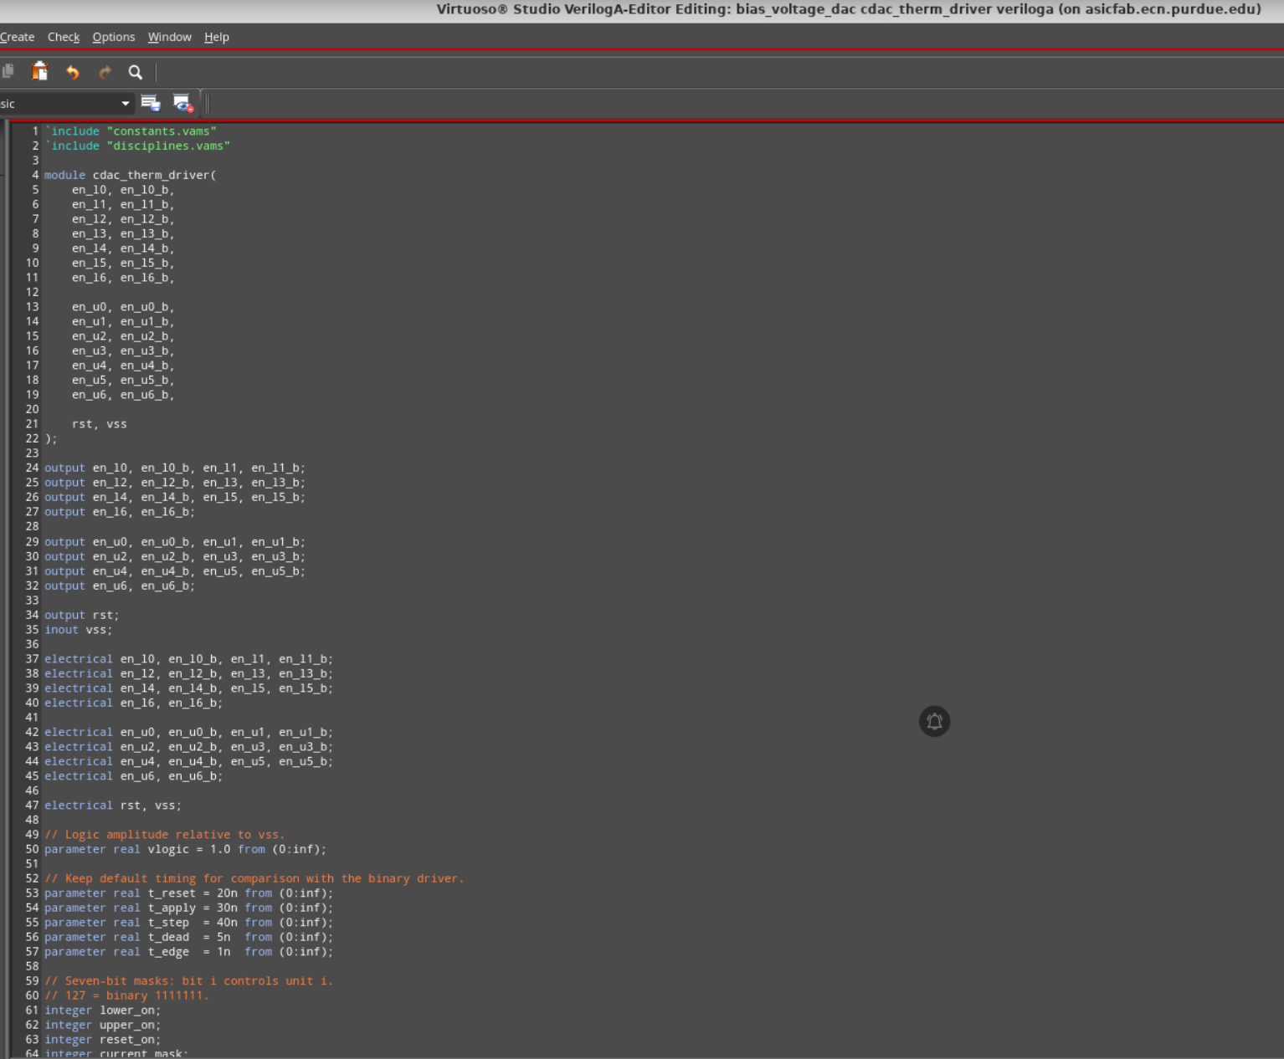
Figure 4. Original editor screenshot of the thermometer driver. This captures code-entry progress; the driver symbol is now synchronized, and the first functional waveform is shown later in this report.

Thermometer testbench wiring
The testbench now contains cdac_therm_driver and cdac_3b_n65_therm_mosrst_oct31. The screenshot shows 28 corresponding control wires and matching rst net labels. The intended connections are VDD/Vu to w1v (1 V), VSS/Vl and driver vss to w0v (0 V), and the output labeled Vout. The user reports that the regenerated driver symbol no longer produces a port mismatch.
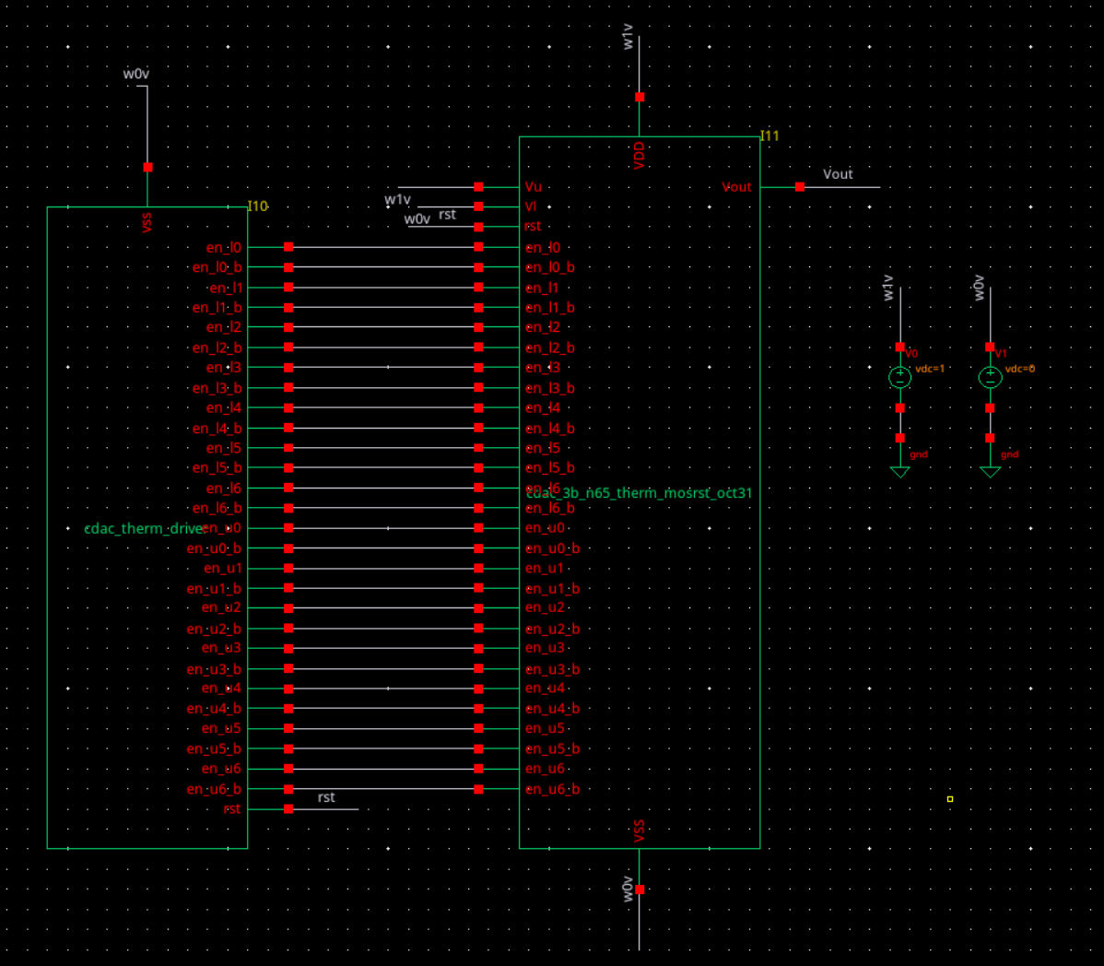
Figure 5. Original screenshot of the assembled thermometer testbench wiring. This records the assembled wiring. A first transient is shown later, with TT, 27 C and reset sizing confirmed by the user. Formal netlist connectivity and effective numerical settings remain to be audited.

First thermometer transient results
The 0-400 ns run shows codes 0 through 7 and the second reset at 350-370 ns. Conditions: tt_lib, 27 C, reset W=0.5 um/L=60 nm, 1 V reference span. Figure 7 also shows no visible undershoot during the 3-to-4 transition. The table summarizes sampled plateau values and the available same-size binary MOS-reset reference.
Code | Ideal  (mV) | Thermometer  (mV) | Error  (uV) | Binary MOS  (mV) | Lower by  (uV)
1 | 125 | 124.7434 | -256.6 | N/A | N/A
2 | 250 | 249.6993 | -300.7 | N/A | N/A
3 | 375 | 374.6469 | -353.1 | N/A | N/A
4 | 500 | 499.5946 | -405.4 | 499.6032 | 8.6
5 | 625 | 624.5478 | -452.2 | N/A | N/A
6 | 750 | 749.4997 | -500.3 | N/A | N/A
7 | 875 | 874.4462 | -553.8 | 874.4587 | 12.5
Error = thermometer minus ideal. Lower by = binary minus thermometer; positive means the thermometer value is lower. N/A means a corresponding binary MOS-reset marker was not recorded. The earlier ideal-reset results are a separate baseline and are not substituted.

Sampling conditions and comparison limits
Thermometer code 1-7 sample times (ns): 92.84828, 135.4028, 172.9038, 212.8742, 252.8638, 292.8422 and 337.3233. Binary samples: code 4 at 223.1007 ns and code 7 at 343.902 ns. Different times and unverified numerical equivalence prevent a firm accuracy-penalty conclusion. Only two codes have a direct numerical comparison.
The zoom gives code 3 = 374.7577 mV at 193.0839 ns, 110.8 uV above the earlier code-3 sample, and code 4 = 499.594 mV at 198.6432 ns. The code-3 difference warrants common-time sampling and control/bottom-plate inspection; it is not a measured hold-drift rate. These are finite-time readings, not validated final steady-state values. Offset, gain error and INL/DNL have not been separated.

Thermometer waveform evidence
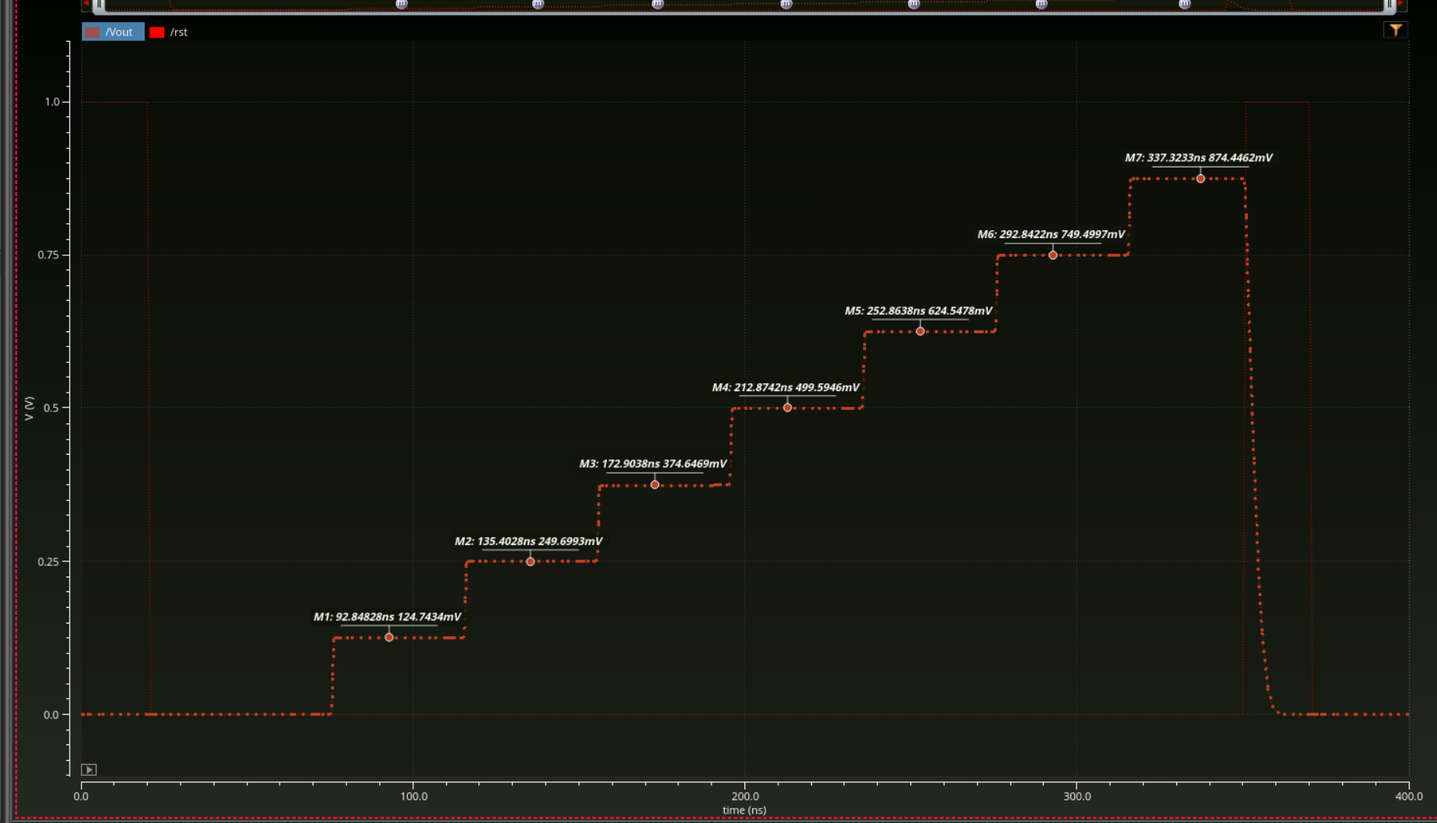
Figure 6. Original nominal thermometer waveform with seven voltage markers and rst. The staircase and second reset are visible. Figure 7 provides the code 3-to-4 zoom; the comparison table uses the seven original markers consistently.

Code 3 to 4 transition detail
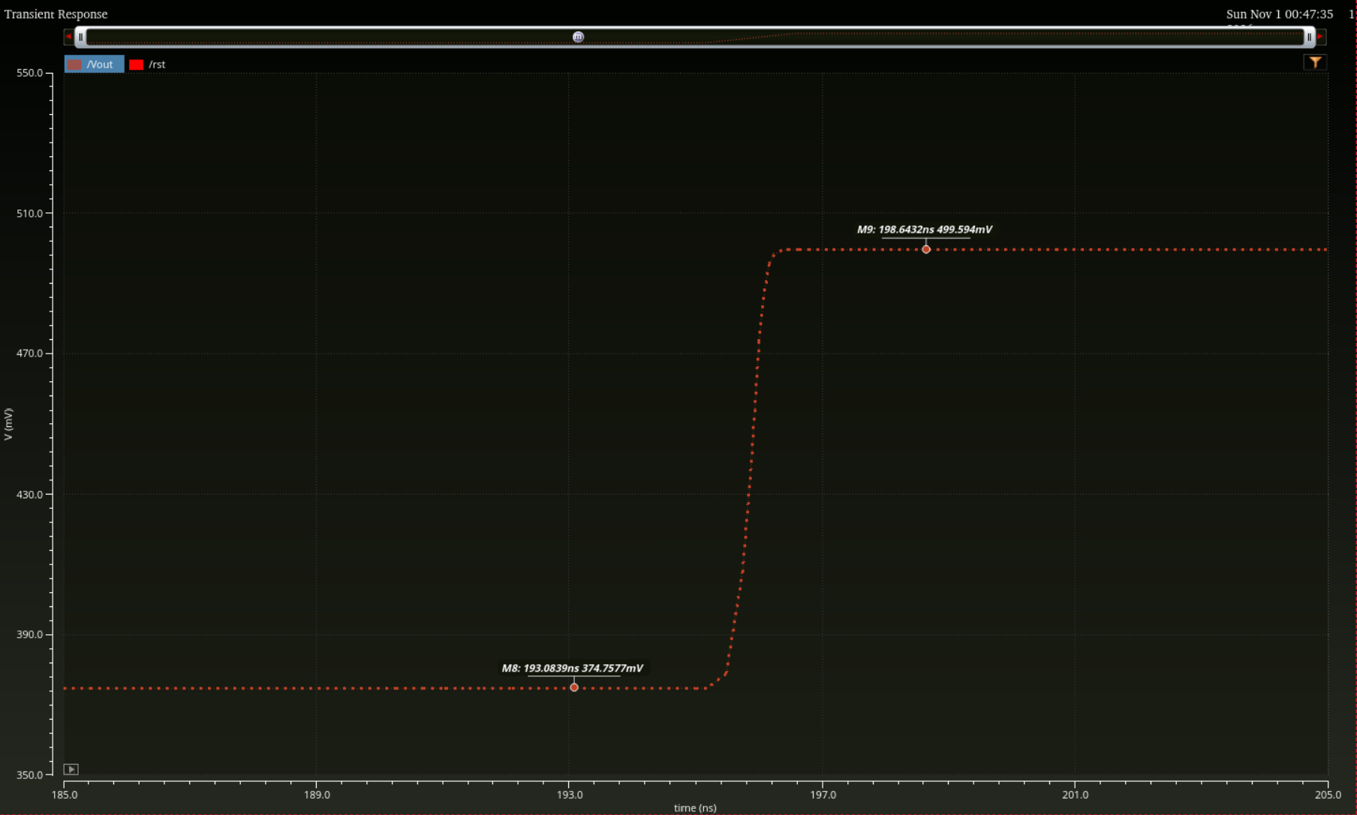
Figure 7. Original 185-205 ns zoom with a 350-550 mV vertical range. M8: 193.0839 ns, 374.7577 mV. M9: 198.6432 ns, 499.594 mV. The visible transition rises without a resolved undershoot or overshoot. This establishes no visible dip at the displayed resolution, not mathematically zero glitch or a specified settling time.

